Instruction of public search engine

The library has set up a public retrieval machine to facilitate students to inquire about the books. OPAC (Online Public Access Catalogue), that is Online Public Catalogue inquiry system, shall be used for collection Catalogue inquiry. The instructions are as follows.

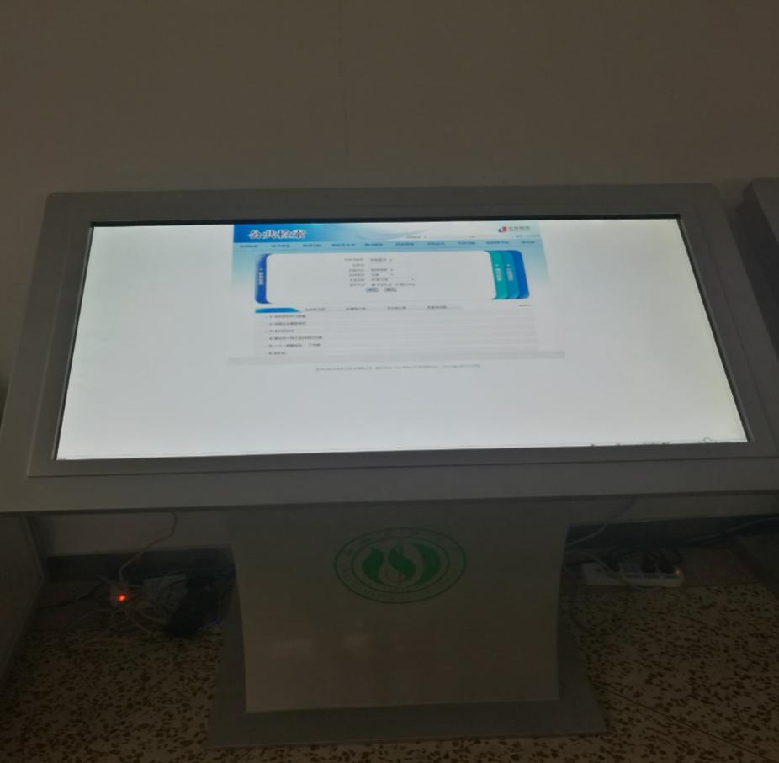

**一、books and periodicals retrieval**

1. Enter the search criteria in the search box. For example, we want to find a book on gynecology. If we know the name of the book is "gynecology", we can choose "exact match".

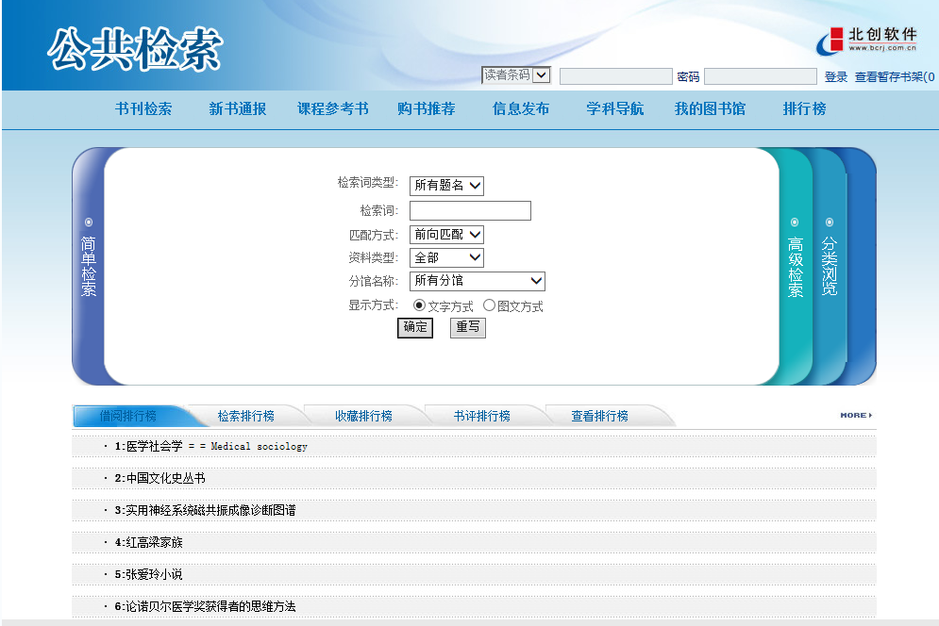

**检索框**



2. Display the search results, including the book bar code number, collection department, circulation status and other information. After checking out, select the book we want, click "title (details)" to get the detailed information. At the same time, please pay attention to whether there is any surplus on the list and note down its call number. Click on the details to see if it belongs to your campus and check its circulation status. With the call number, you can go to the library to find books.

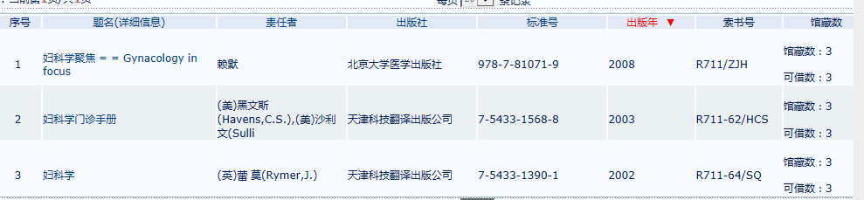

**二、View and modify personal information**

1. You can view personal information after login. User name is reader code number, the initial password is eight birth date.



2. After logging in, you can modify your personal information, query your borrowing information and renew it.

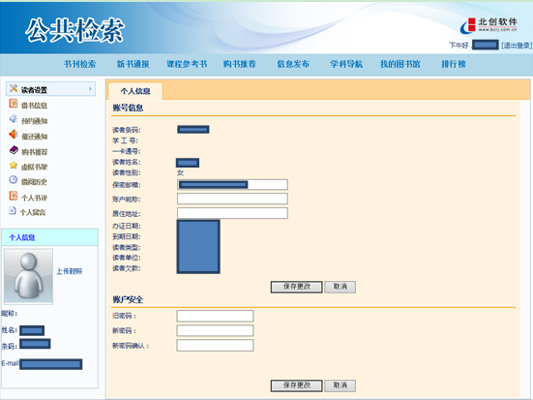

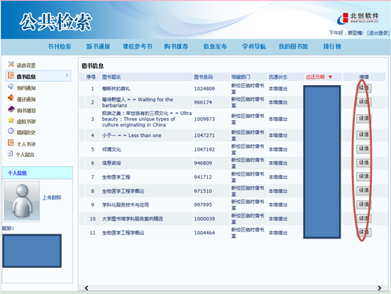

**三、new book bulletin, book recommendation and list**

1. New book bulletin. Click the new books category on the left to view the new books purchased under that category.

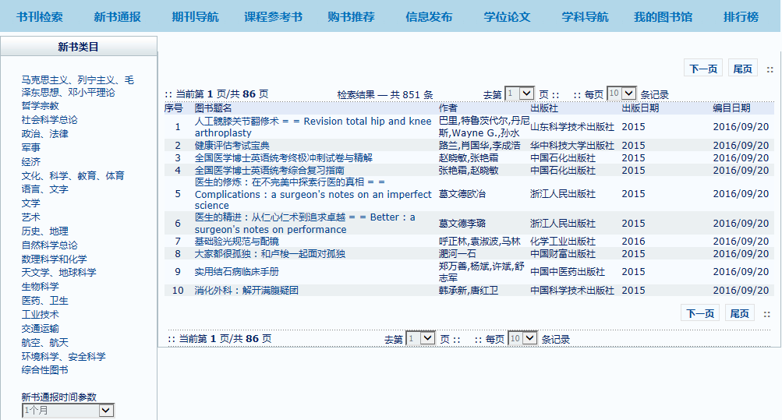

2. Book recommendations. Click the reader's letter of recommendation and input relevant information about the purpose of the letter of recommendation. After submitting the letter, the teachers of the editing department will purchase the required books according to the needs of readers.

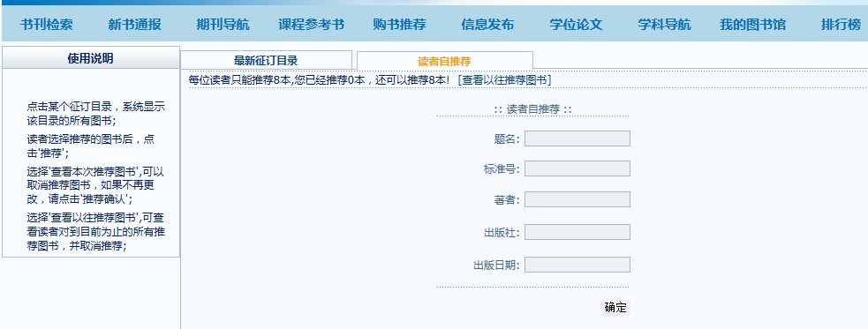

3. Leaderboards. The leaderboards Include borrowing leaderboard, search leaderboard, collection leaderboard, book review leaderboard, view leaderboard, click to view relevant information. 